**Levenshtein Distance**

Levenshtein distance is a string metric for measuring the difference between two sequences. The distance between two words is the minimum number of single-character edits (i.e. insertions, deletions, or substitutions) required to change one word into the other. The formula is as follows:

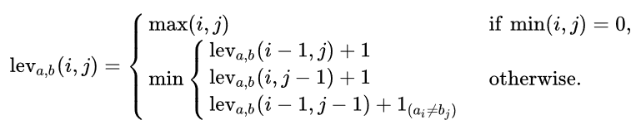

**Format Input**

The first line consists of single integer K which denotes the number of cases. The second line consists of K lines of two string N and M separated by a space; stating the given value of Levenshtein distance.

**Format Output**

Output the calculation of Levenshtein distance with a format “**Case #K: X**”; where K is the number of case and X is the distance value.

**Constraint**

* 3 ≤ |N|, |M| ≤ 100

**Sample Input (standard input)**

|  |
| --- |
| 5  turing turing  bag bay  stay play  binus university  feliz django |

**Sample Output (standard output)**

|  |
| --- |
| Case #1: 0  Case #2: 1  Case #3: 2  Case #4: 8  Case #5: 6 |